<https://putsreq.com/>

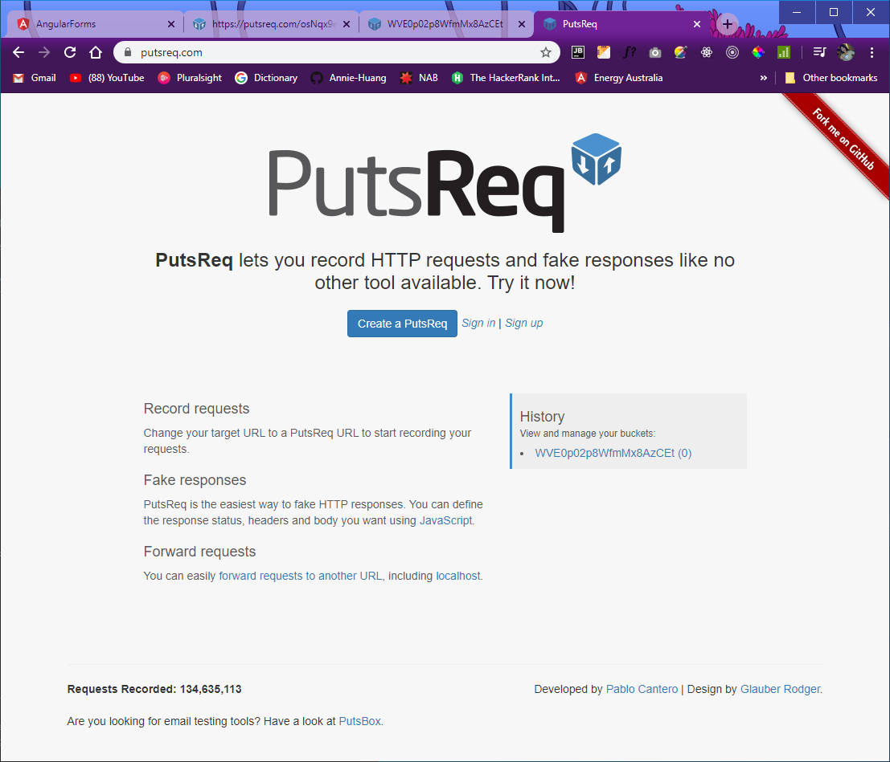

Clicks ‘Create a PutsReq’, It will create a new request:

<https://putsreq.com/WVE0p02p8WfmMx8AzCEt/inspect>

https://putsreq.com/WVE0p02p8WfmMx8AzCEt

Put this into data.service.ts file.

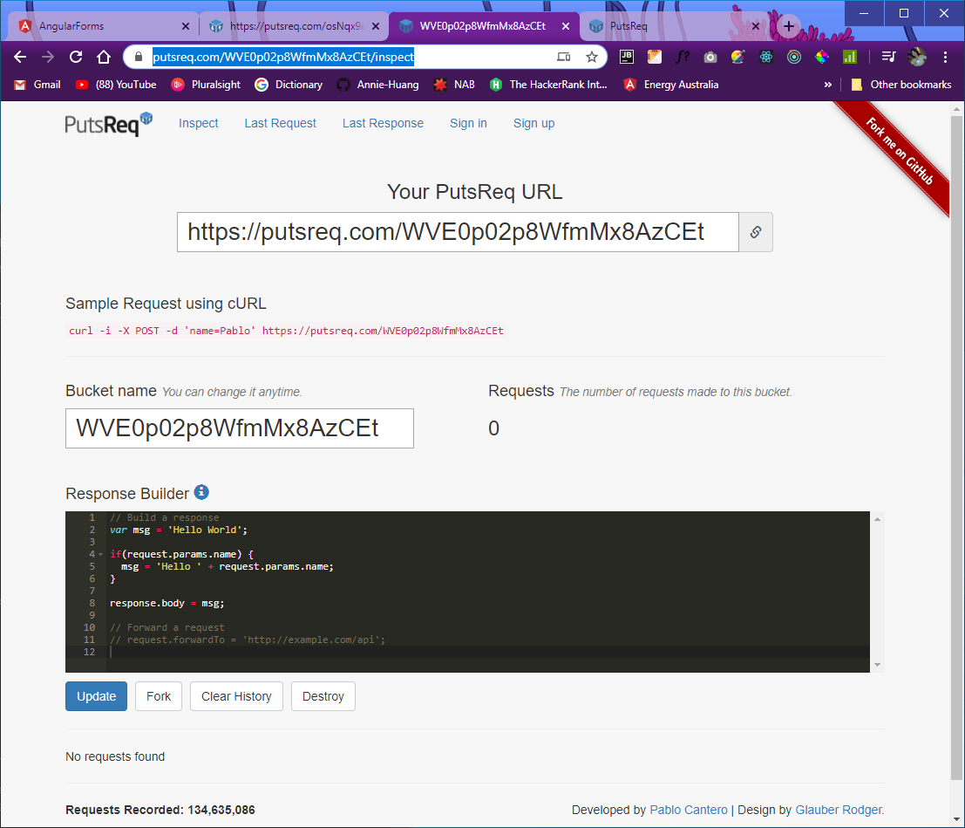

Click into the info tooltip and it will show you to:

<https://github.com/phstc/putsreq#response-builder>

Copy the section of ‘Parsing a JSON request:’ into the Response Builder:

var parsedBody = JSON.parse(request.body)

**SUCCESS CASE:**

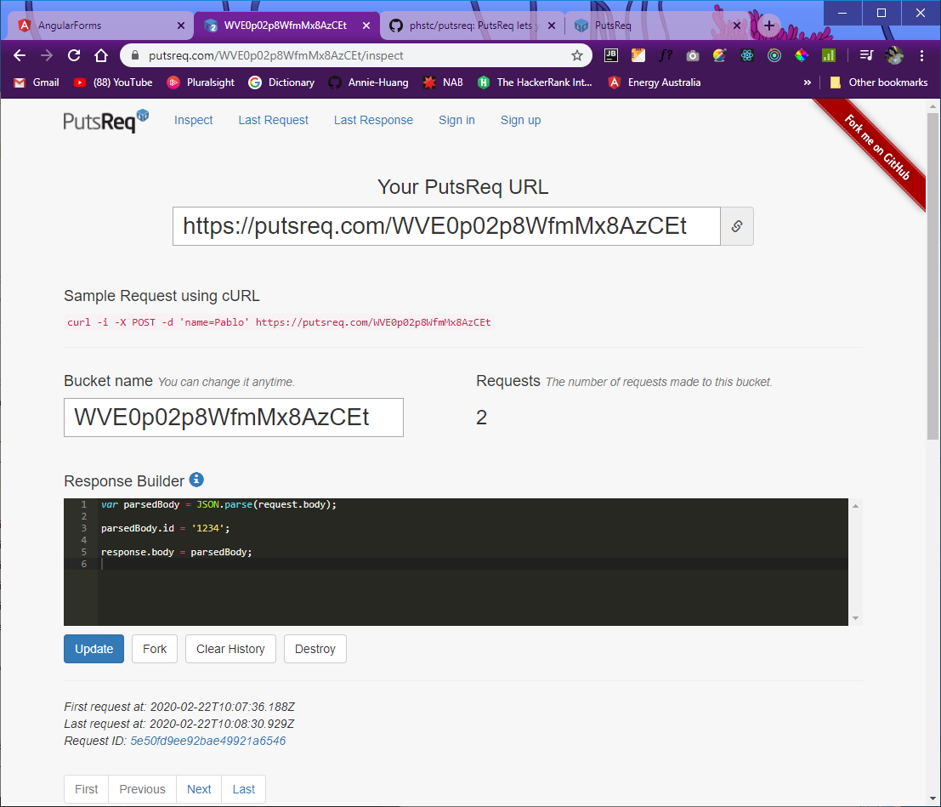

Click Update button.

Now you can click ‘Send’ button your in your localhost:4200 after you fill up the form

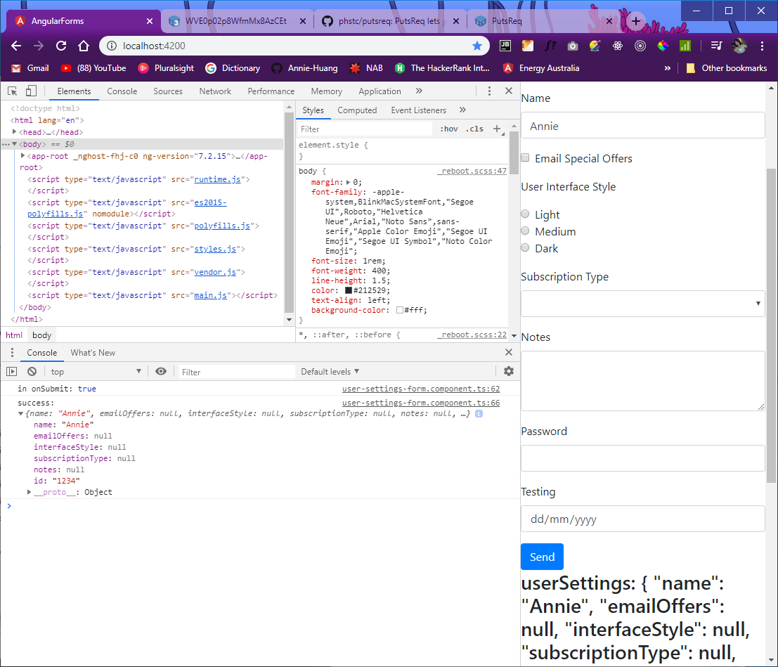

You can also see the request number in the website:

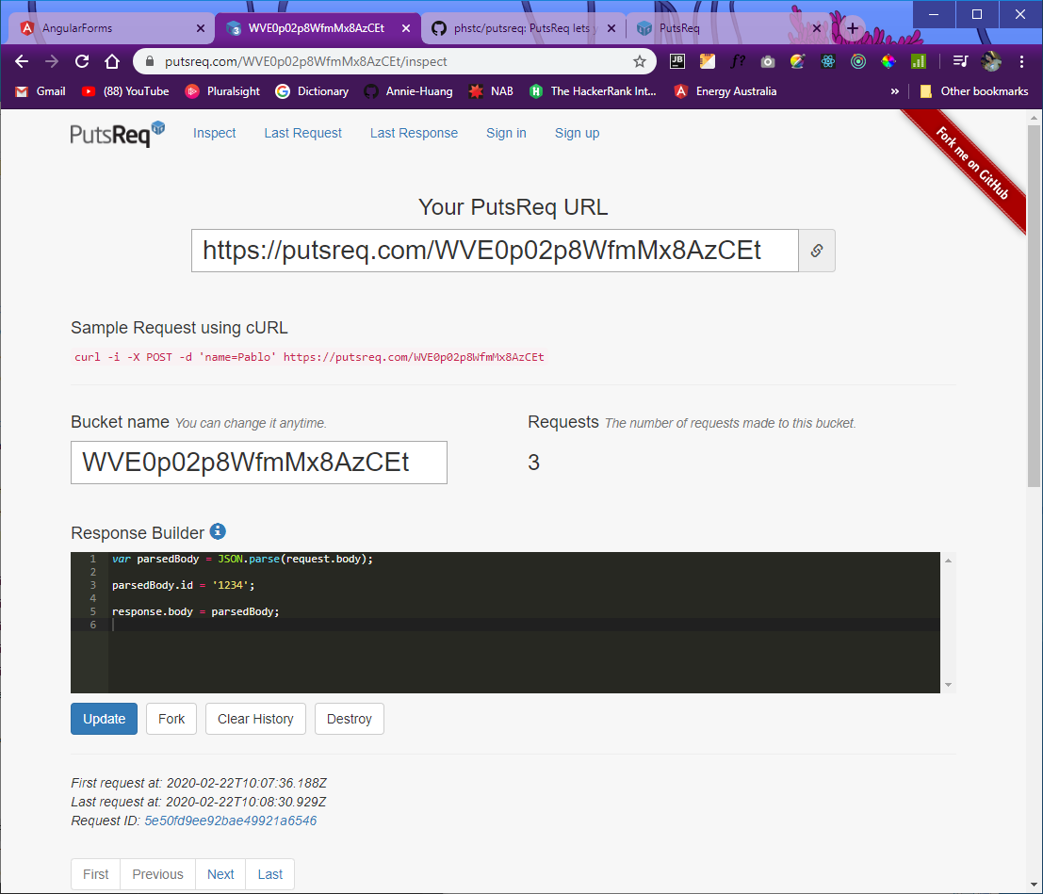

**FAILED CASE:**

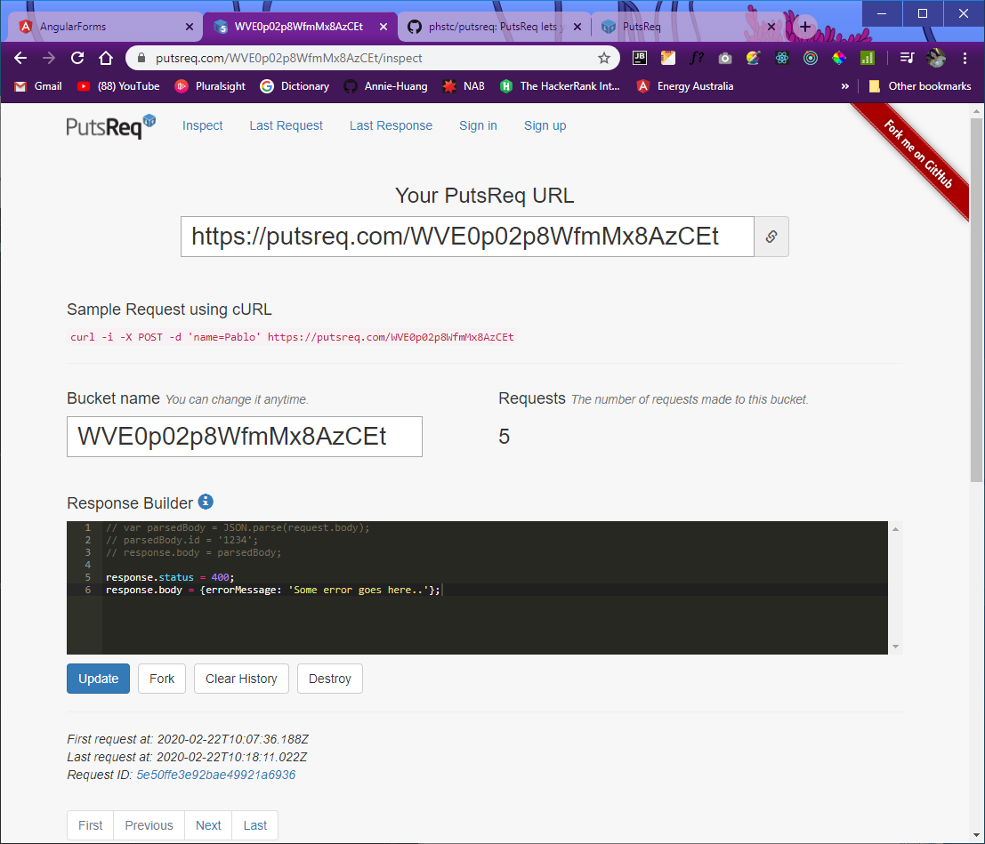

Click ‘Update’ button as usually

